
WHO WE ARE: We are SAKO MASTERS GLOBAL - A strategic creative organization. We offer a One-Stop Project Management Services. Our Management Team facilitate its commitment and productivity, removing obstacles, and are motivating team members. Also our "TEAM" as partners are highly recognized globally on their field of services.
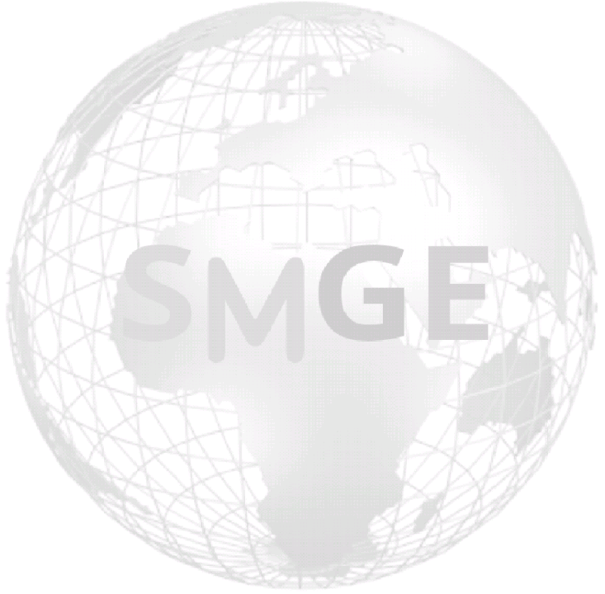
We are an organization totally committed to help unleash creative and strategic concepts towards our key function services. Such as, intercepting between Human Life Experience, Earthly challenges, Developments & Properties.
SMGE is owned by its principal investors and principal operators. The company founders are high skilled, broad based, creative mind experts with vast experience locally and internationally. SAKO MASTERS GLOBAL is managed by both the founders and other working associate, in a structure mainly taken from her international partners.

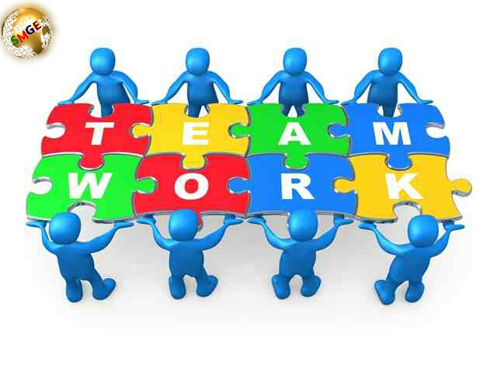
Ties To Our Services!!!
Our engagements to your service; is the process of planning, organizing, motivating and controlling resources, procedures and protocols to achieve specific goals with standard approach.
Our purpose: is to foresee or predict as many dangers and problems as possible; and to plan, organise and control activities so that the project is completed as successfully as possible in spite of all the risks.

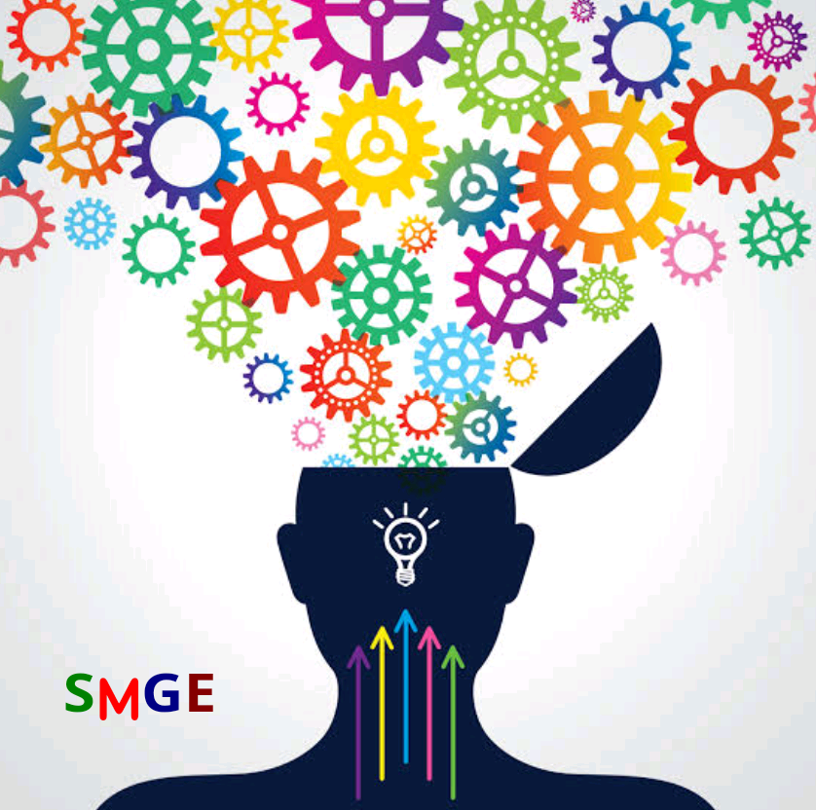
Our reaponsibilities: includes:- Planning, Executing, and Closing Projects — defining the project, building its comprehensive work plan, and managing to the budget.

Our Duties: is to ensure what is being delivered, is right, and to deliver real value against the business & service opportunity. Hence every client has strategic goals and the projects that we do for them is to advance those goals to reality.

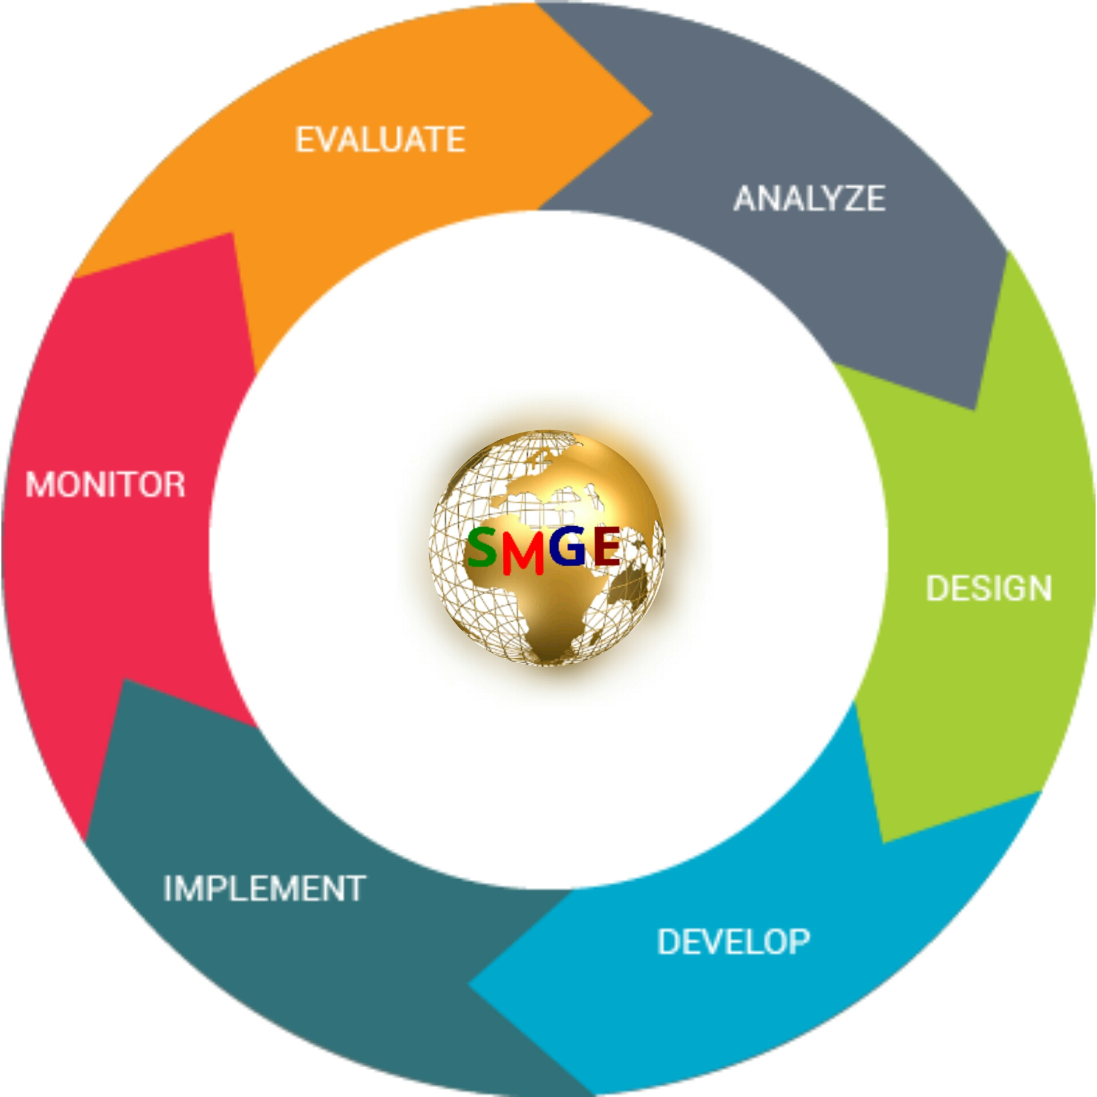
We Start-to-end project: by documenting and describing every phase of a project. The components includes; initiating, planning, executing, monitoring and controlling, and closing. While we caution to management functions (Scope, Time, Human resource, Communication, Quality, Contract / procurement, Risk, Project integration).

THIS IS WHO WE ARE!!!
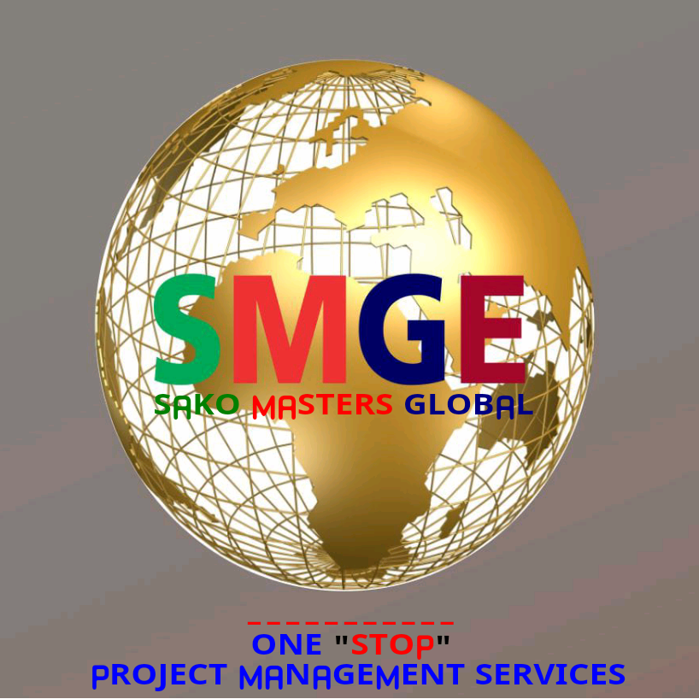
Enquiry;
Email: info@smgeservices.com
Website: www.smgeservices.com
Tel/Whatsapp: +234 902 246 6666
+234 803 471 4867

